

**SCHOOL OF COMPUTING SCIENCE & ENGINEERING**

BCS01T1001

Data Analytics Using Excel and Tableau

LAB MANAUL

SESSION 2021-2022 YEAR – 1ST SEMESTER – 1

SUBMITTED BY – SUBMITTED TO-

***ABHINAV KUMAR CHOUDHARY* Mr. ABHIST KUMAR**

**Roll. No. – *21SCSE1011615***

**INBOX**

|  |  |  |  |
| --- | --- | --- | --- |
| **S No.** | **DATE OF SUBMISSION** | **LIST OF EXPERIMENTS** | **Teacher’s**  **Signature** |
| **1.** |  | **Installing Data Analysis Tool in Excel, Reading and Manipulating**  **data in Excel** |  |
| **2.** |  | **To Perform Basic Operations and Functions using Excel** |  |
| **3.** |  | **Working with Formulas and Functions in Excel** |  |
| **4.** |  | **Working with Filtering Operations, Pivot tables and charts using Excel** |  |
| **5.** |  | **Working with Histogram and Descriptive Statistics in Excel** |  |
| **6.** |  | **Working with Moving Average and Exponential Smoothing** |  |
| **7.** |  | **Working with Correlation and Regression in Excel** |  |
| **8.** |  | **Installing Tableau Public - Getting Data and visualizing data on maps** |  |
| **9.** |  | **Advanced Graphing and Charting in Tableau** |  |
| **10.** |  | **Perform Real Word Data Analysis using Excel and Tableau** |  |

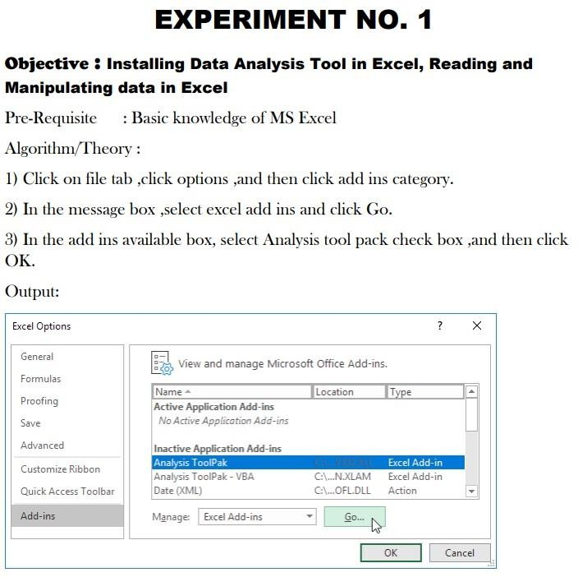

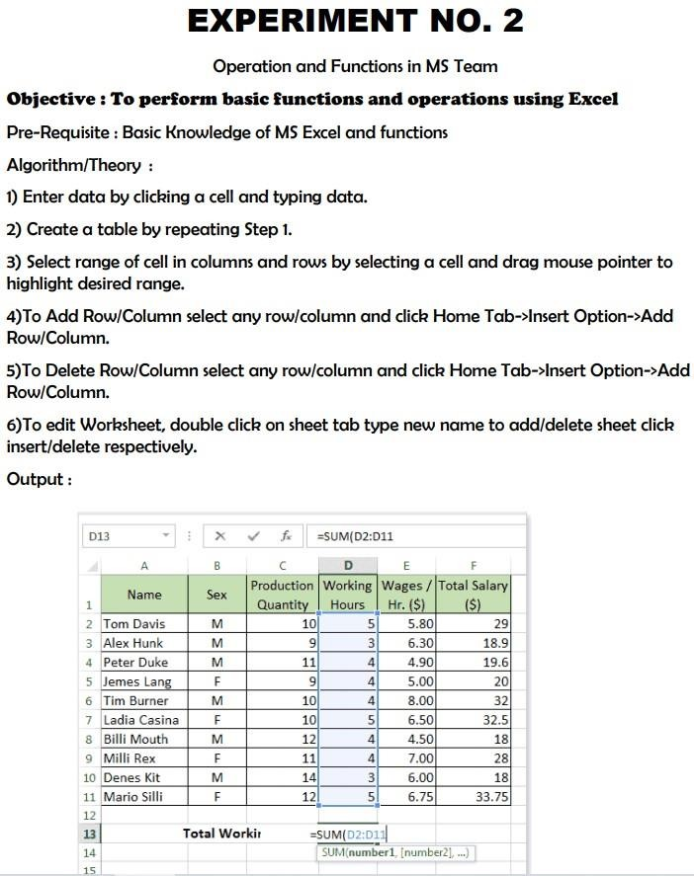

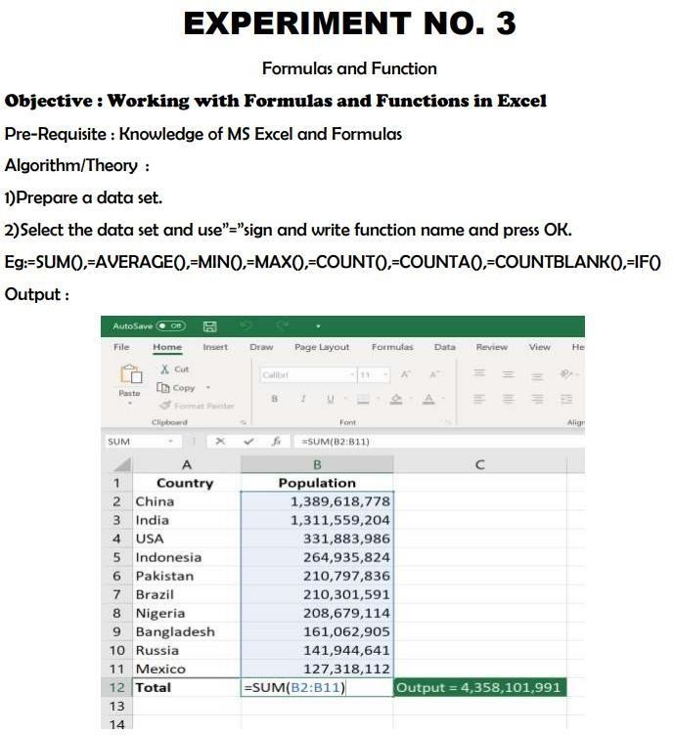

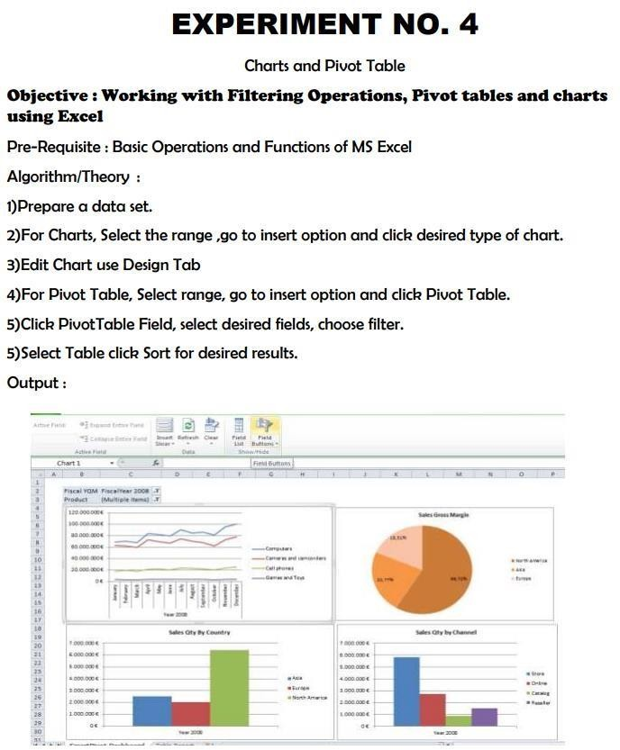

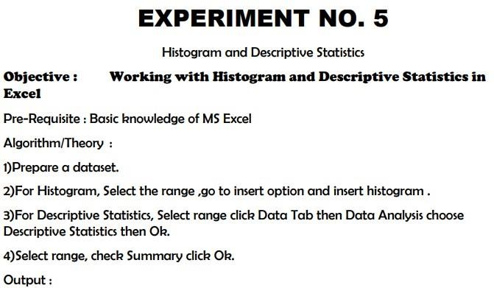

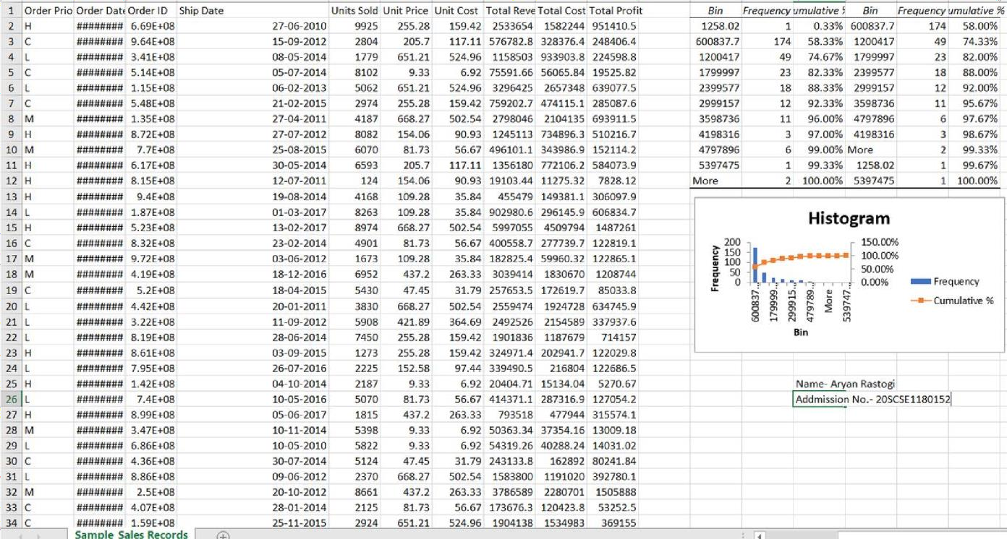

HISTOGRAM

DESCRIPTIVE STATISTICS

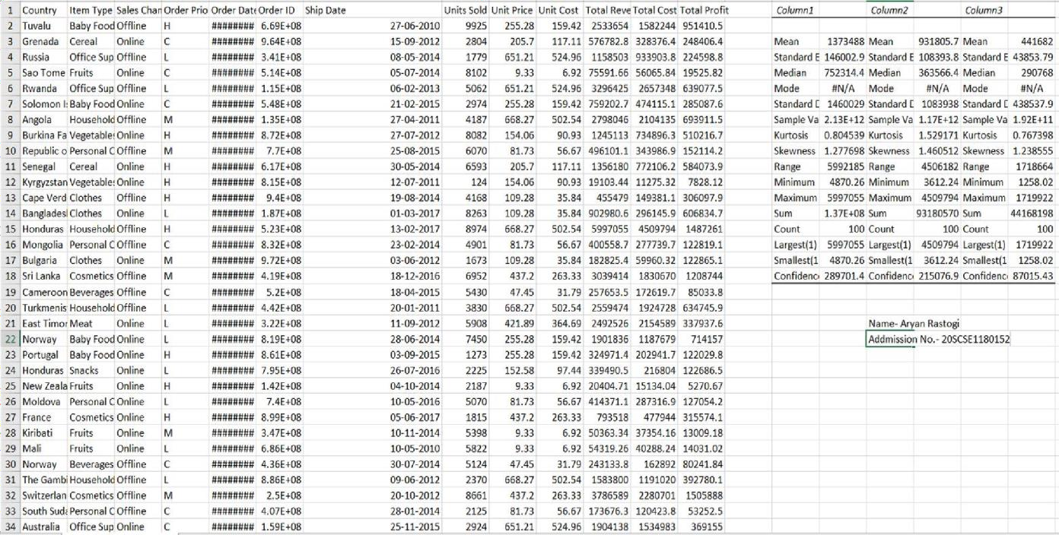

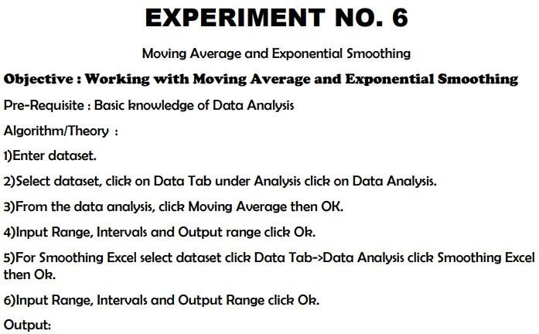

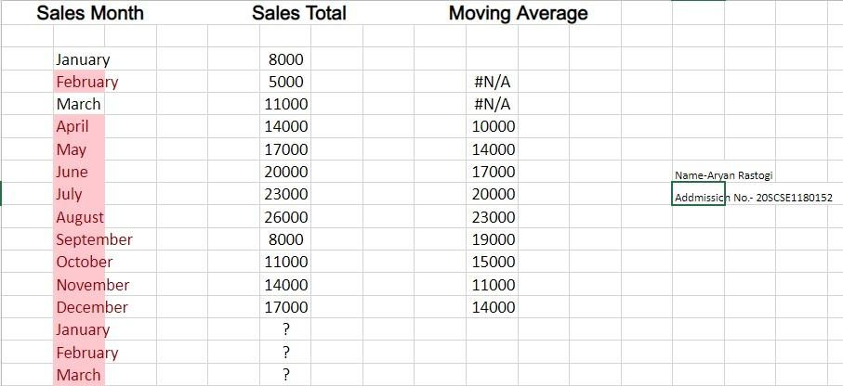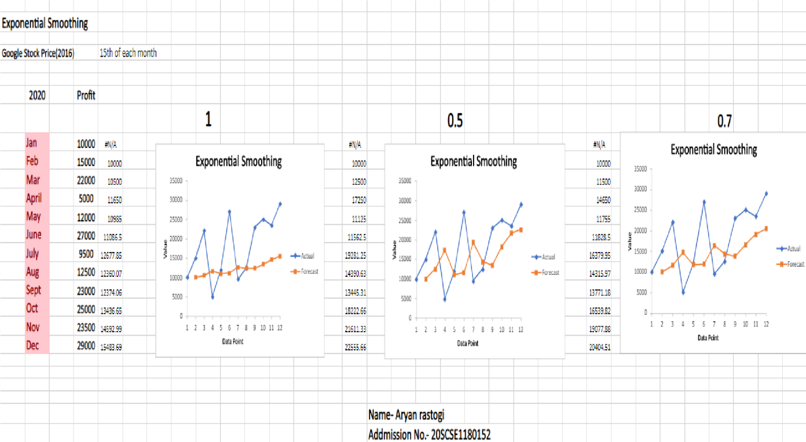

Moving Average EXPONENTIAL SMOOTHING

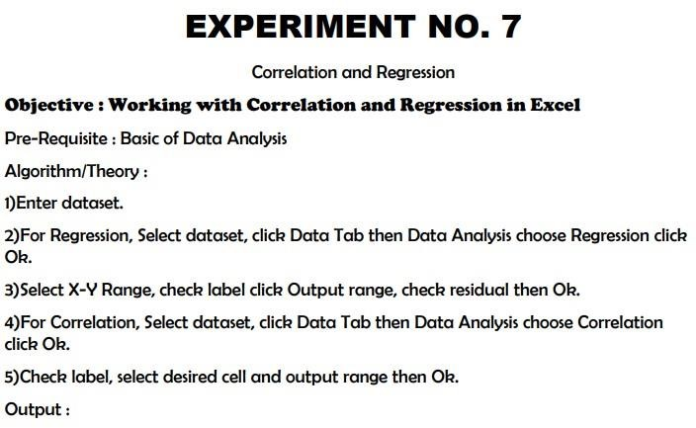

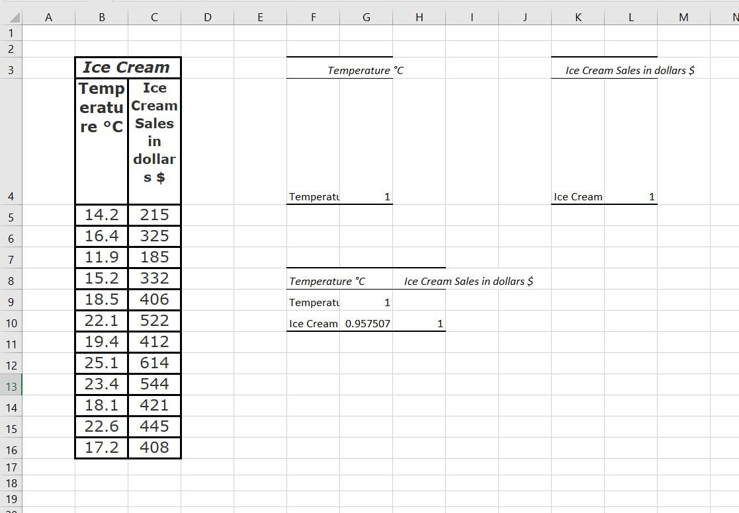

Correlation

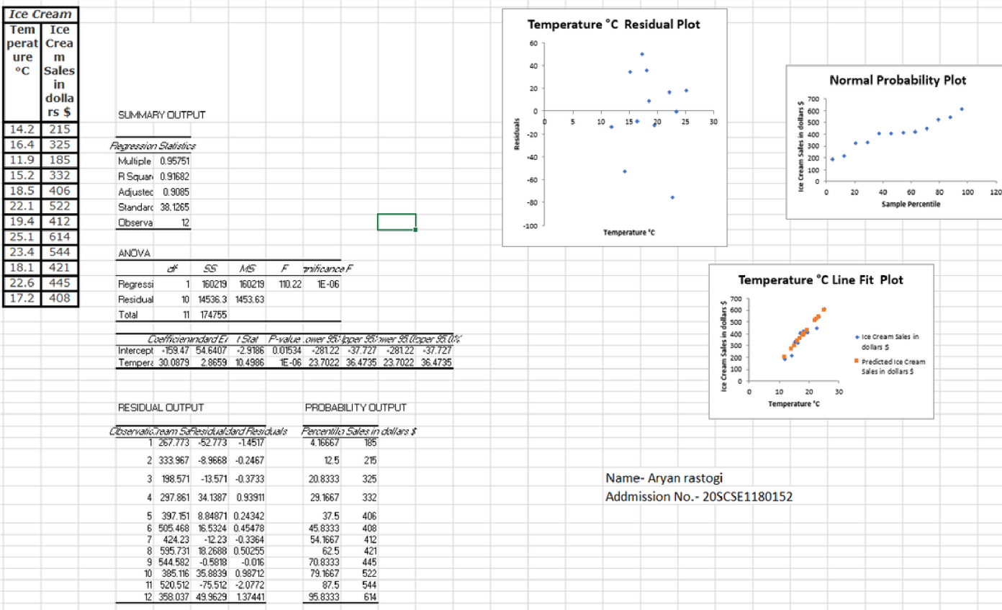

Regression

